Student Enrollment & Course Management System (SECMS)

User Story:
The Student Enrollment & Course Management System is a comprehensive Salesforce application designed to streamline and automate the academic enrollment operations of an educational institute. This system enables administrators, enrollment officers, and instructors to efficiently manage student records, course offerings, enrollments, instructor assignments, approval processes, payments, and reporting—all within a unified Salesforce environment.

1. INTRODUCTION

1.1 Project Overview :

This project aims to centralize all student, course, and enrollment-related data within a single Salesforce application to ensure easy data access, structured workflows, and accurate reporting. The system allows Enrollment Officers to manage student admissions, course registrations, and communication effectively, while instructors and administrators gain full transparency into course allocations and academic progress. The solution also enables automated instructor assignment, task creation, validation checks, and multi-level approval processes for enrollment management.

With Salesforce Flows, Approval Processes, Validation Rules, Reports, and Dashboards, the organization can ensure that all enrollment operations—from admission to course completion—are handled systematically and with continuous monitoring of key performance indicators such as enrollment volume, revenue, student status distribution, and pending approvals.

1.2 Purpose :

The primary purpose of SECMS is to replace manual and fragmented enrollment processes with a scalable, automated, and secure Salesforce solution that ensures:

Accurate student data management
Structured enrollment workflows
Automated approvals and validations
Transparent reporting and monitoring

2. IDEATION PHASE
PS | I am (Customer) | I’m trying to | But | Because | Which makes me feel
PS-1 | Enrollment Officer | Manage student enrollments efficiently | enrollment data is scattered | systems are manual and unintegrated | frustrated and error-prone
PS-2 | Administrator | track enrollments and revenue | reporting is delayed | data is not centralized | uncertain in decision-making
2.1 Problem Statement (Customer Problem Statement Template)

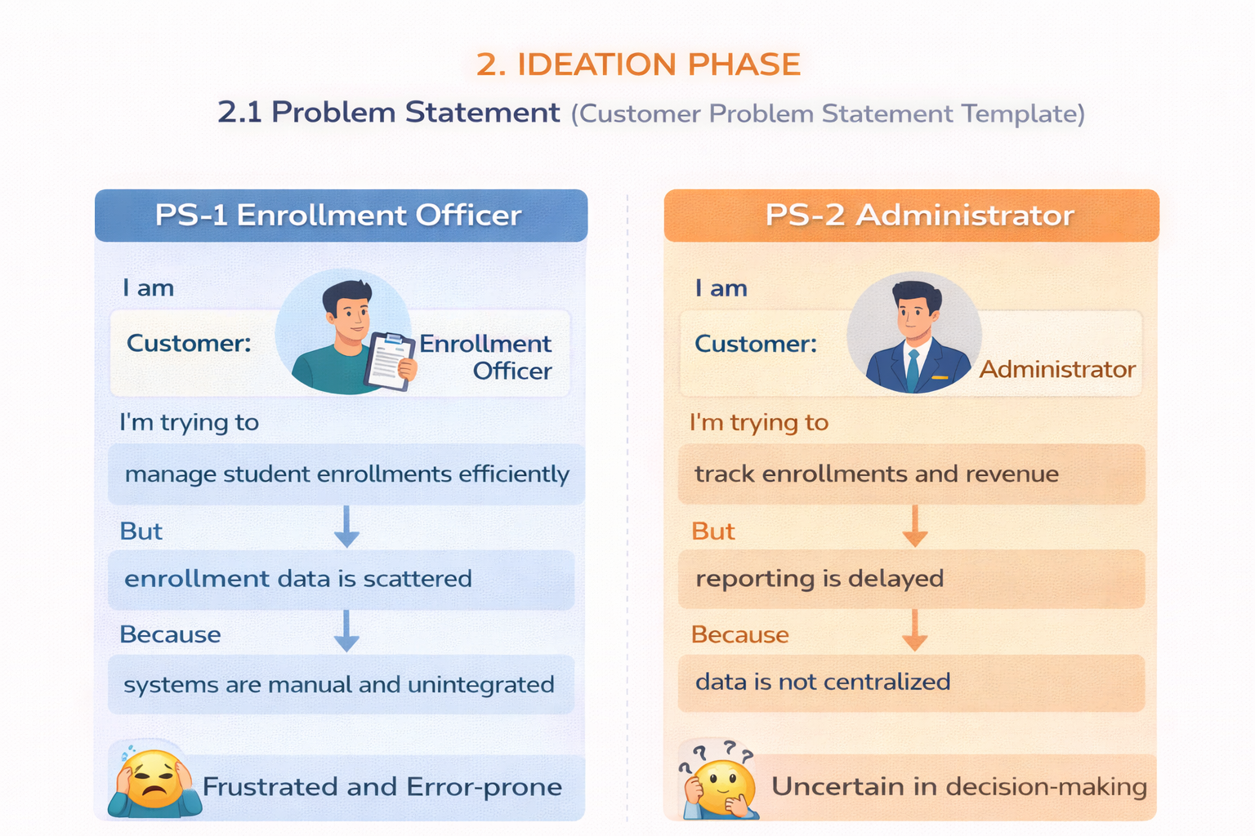

2.2 Empathy Map Canvas
User Persona: Enrollment Officer
- Think & Feel: Concerned about double bookings and revenue loss
- Hear: Complaints from students and management
- See: Multiple spreadsheets and emails
- Say & Do: Rechecks data, follows up manually
- Pain: Duplicate entries, approval bottlenecks
- Gain: Automation, dashboards, faster processing
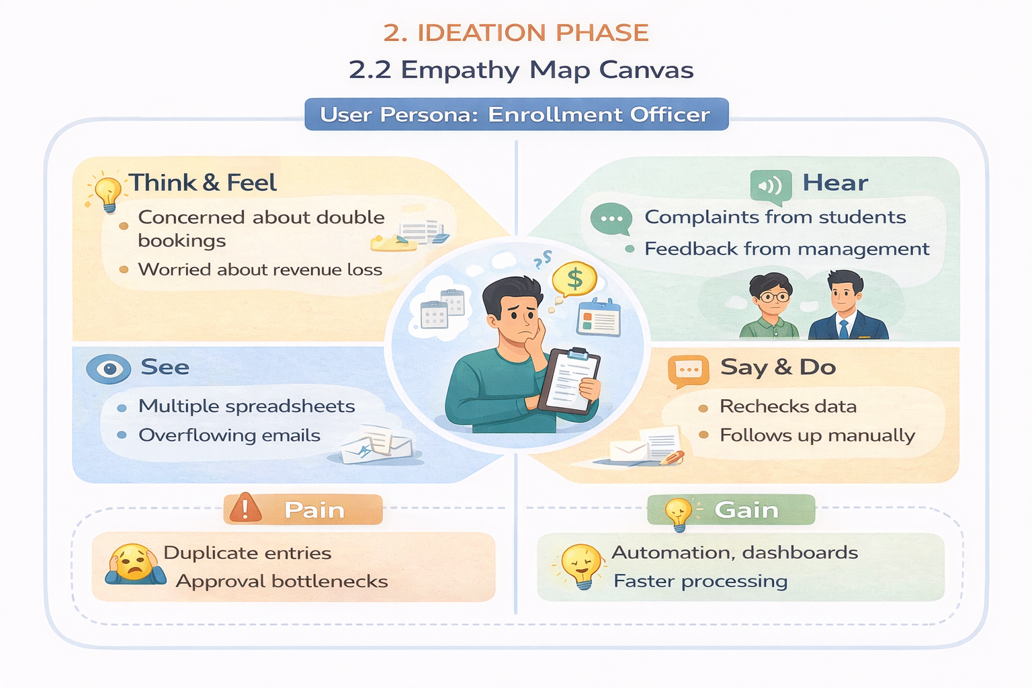

2.3 Brainstorming & Idea Prioritization
Step 1 – Brainstormed Ideas
- Spreadsheet automation
- Standalone enrollment portal
- ERP integration
- Salesforce-based enrollment system
Step 2 – Grouping
- Manual solutions
- Semi-automated solutions
- Fully automated cloud solutions
Step 3 – Prioritization
Salesforce-based SECMS was selected due to high feasibility and high impact.

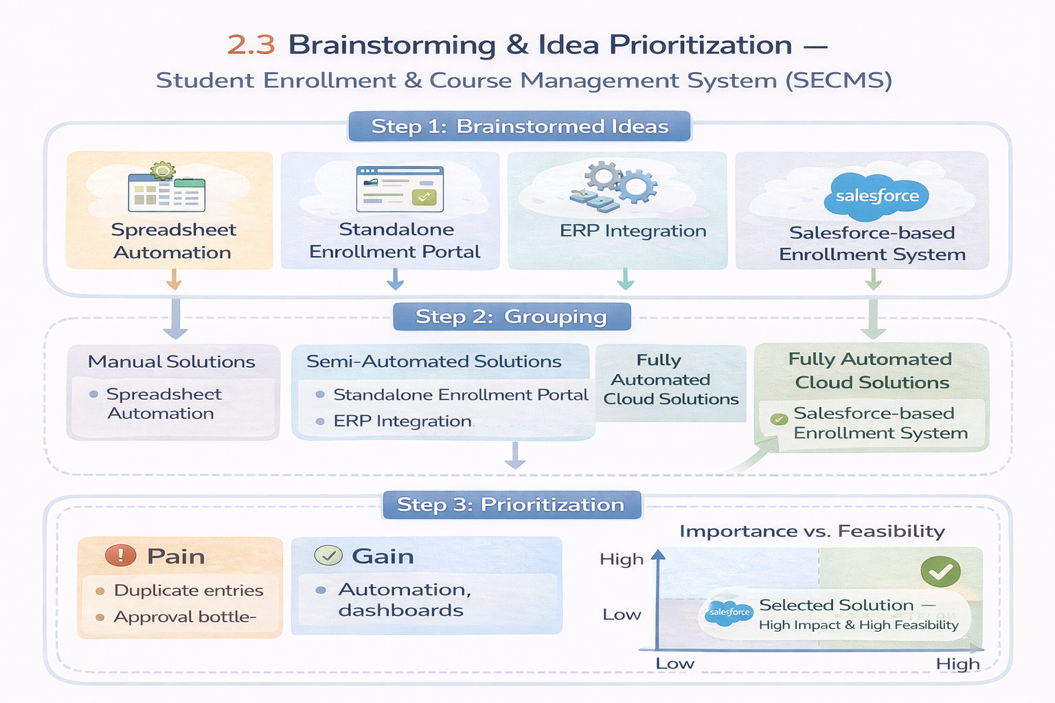

3.REQUIREMENT ANALYSIS PHASE

3.1 Customer Journey Map
Stages covered:
- Awareness & Registration
- Course Selection
- Enrollment Request
- Fee Payment
- Approval
- Instructor Assignment
- Reporting & Completion

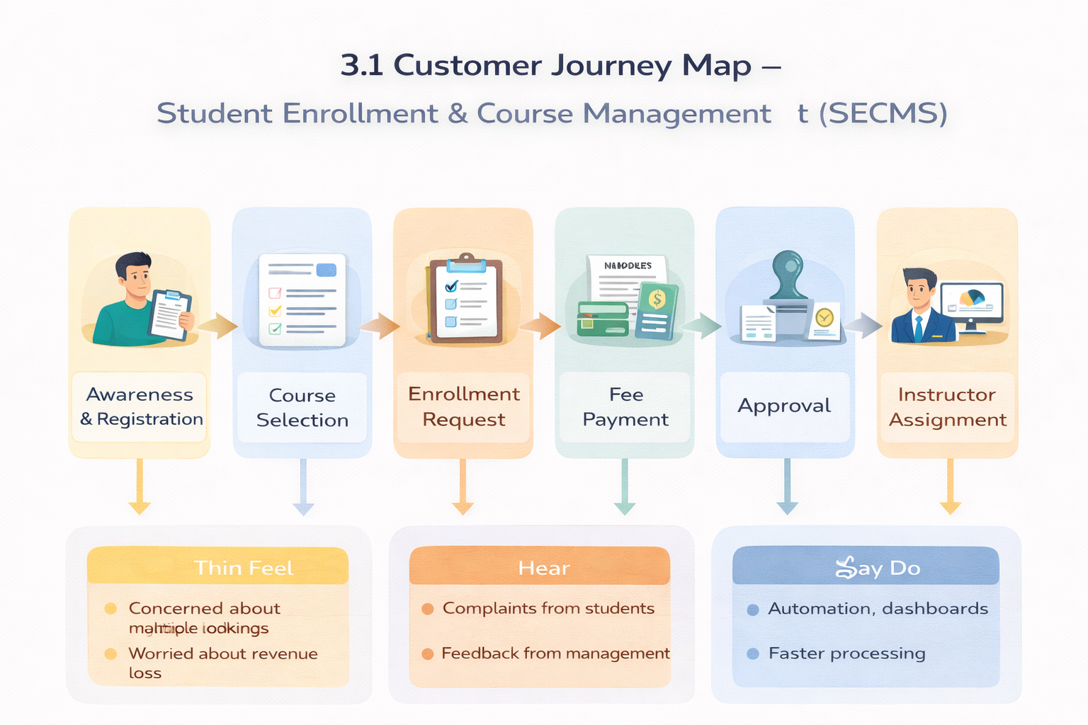

3.2 Solution Requirements
Functional Requirements

FR No | Epic | Description
FR-1 | Student Management | Manage student records
FR-2 | Course Management | Create and manage courses
FR-3 | Enrollment Processing | Request, approve, reject enrollments
FR-4 | Instructor Assignment | Auto-assign instructors
FR-5 | Reporting | Dashboards and reports

Non-Functional Requirements
NFR-1: Usability
The system shall provide a simple, intuitive, and user-friendly interface that enables enrollment officers, administrators, instructors, and students to perform operations efficiently with minimal training. Navigation shall be organized through clearly labeled tabs, dashboards, and forms to reduce user effort and errors.
Examples:
- Quick student registration form
- One-click enrollment approval
- Role-based dashboards
NFR-2: Security
The system shall ensure the confidentiality, integrity, and protection of student and institutional data through secure authentication, authorization, and access controls. Sensitive information such as personal data, enrollment history, and academic records shall only be accessible to authorized users.
Examples:
- Only admins can modify course details
- Instructors view only assigned students
- Students cannot access other student records
NFR-3: Reliability
The system shall operate consistently and accurately without failures during enrollment processing, approvals, and reporting. Automation logic shall execute correctly to avoid duplicate or incorrect enrollments.
Examples:
- No duplicate course registration
- Accurate status updates after approvals
- Consistent report generation
NFR-4: Performance
The system shall provide fast response times for all operations to ensure smooth and uninterrupted user experience, especially during peak admission periods.
Examples:
- Quick dashboard refresh
- Fast search for student records
- No lag during bulk uploads
NFR-5: Scalability
The system shall support future growth in the number of students, courses, departments, and users without degradation in performance or functionality. It shall allow easy addition of new modules and features.
Examples:
- Add new departments without redesign
- Handle increased admissions annually
- Extend to mobile or portal integration

NFR-6: Availability
The system shall be continuously accessible to users during institutional working hours and must minimize downtime. The platform shall support high availability for academic operations.
Examples:
- 24/7 cloud access
- Reliable during peak admission season
- Automatic backup of student records

3.3 Data Flow Diagram
- User inputs student and enrollment data
- System validates and stores records
- Approval process routes data
- Reports and dashboards consume processed data.
The system processes enrollment requests, validates data, routes approvals, assigns instructors, and generates reports.
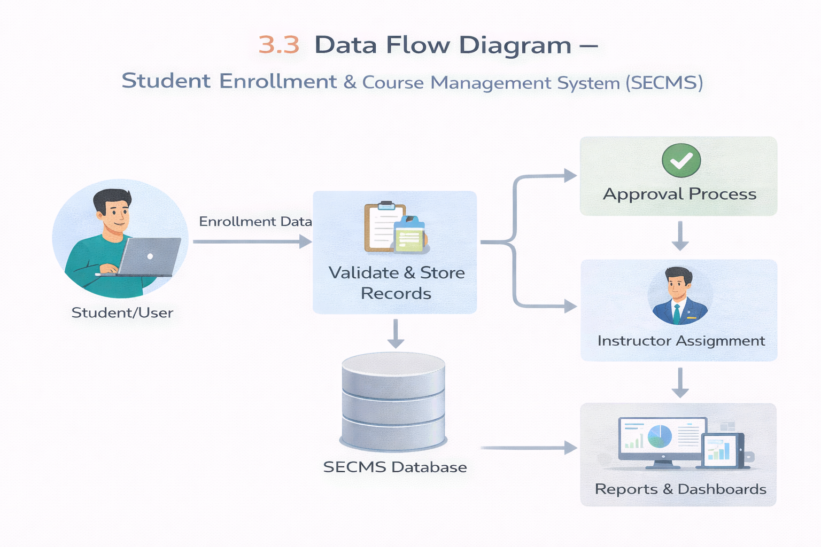

3.4 Technology Stack
Layer | Technology
UI | Salesforce Lightning
Logic | Salesforce Flows
Database | Salesforce Objects
Automation | Validation Rules, Approval Process
Reporting | Reports & Dashboards

4. PROJECT DESIGN PHASE

4.1 Problem–Solution Fit
SECMS directly addresses fragmented enrollment workflows by aligning user behavior, constraints, and automation using Salesforce-native capabilities.
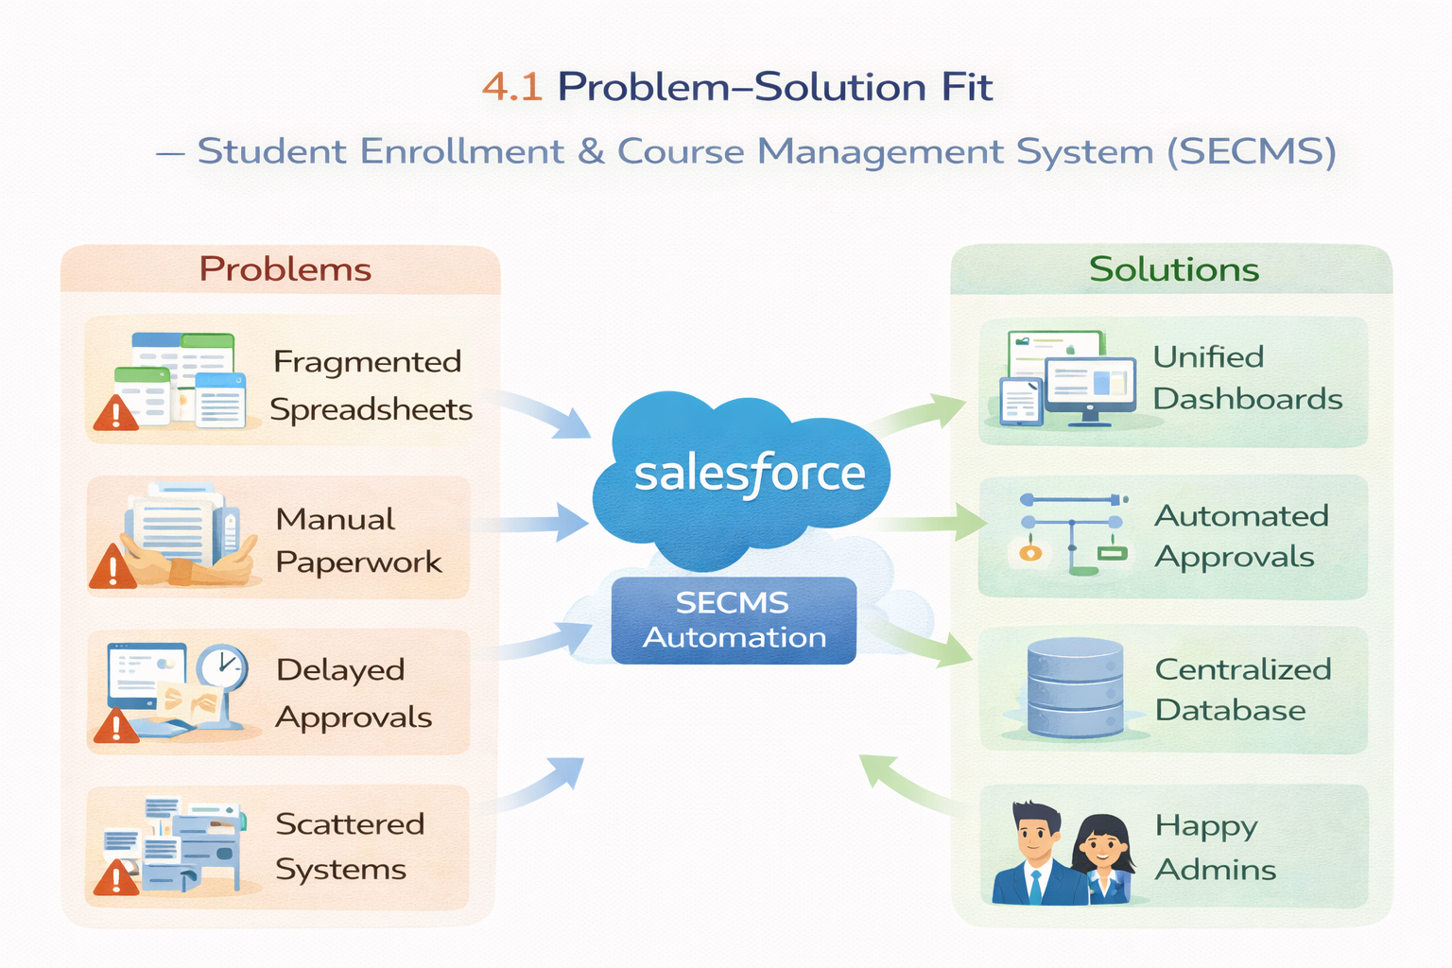

4.2 Proposed Solution
Functional Requirements

Parameter | Description
Problem | Manual enrollment handling
Solution | Salesforce-based SECMS
Novelty | End-to-end automation
Social Impact | Improved student experience
Revenue Model | Institutional deployment
Scalability | Multi-department support

4.3 Solution Architecture
Sprint | Functional Requirement (Epic) | User Story Number | User Story / Task | Story Points | Priority | Team Members
Sprint-1 | Developer Setup | USN-1 | As a system administrator, I want to create a Salesforce developer account so that I can configure and deploy the Student Enrollment system.. | 1 | High | Member1
Sprint-1 | Data Modeling | USN-2 | As an admin, I want to create custom objects for Student, Course, Enrollment, and Instructor so that academic data can be stored and managed efficiently. | 3 | High | Member2
Sprint-2 | Data Modeling | USN-3 | As a user, I want dedicated tabs for each object so that I can easily navigate between students, courses, enrollments, and instructors. | 3 | High | Member3
Sprint-2 | Data Modeling | USN-4 | As an admin, I want to create relevant fields such as student details, course information, and enrollment status so that complete records can be captured accurately. | 5 | High | Member4
Sprint-2 | Data Modeling | USN-5 | As an enrollment officer, I want a centralized Lightning App so that I can access all academic operations from one interface. | 3 | High | Member4
Sprint-2 | Data Modeling | USN-6 | As an admin, I want to define relationships between students, courses, and enrollments so that the system can logically link and track academic activities. | 5 | Medium | Member1
Sprint-2 | Data Modeling | USN-7 | As a user, I want customized page layouts so that only relevant information is displayed, improving clarity and ease of data entry. | 5 | High | Member2
Sprint-3 | Automation | USN-8 | As a system, I want to validate input data such as mandatory fields and enrollment limits so that incorrect or incomplete records are prevented. | 3 | High | Member4
Sprint-3 | Automation | USN-9 | As a system, I want automated flows to handle enrollment processing and notifications so that manual effort is reduced and processes become faster. | 3 | High | Member4
Sprint-3 | Automation | USN-10 | As an administrator, I want an approval process for enrollment requests so that registrations are verified before confirmation. | 5 | High | Member1
Sprint-4 | Security | USN-11 | As an admin, I want to configure role-based security so that users can only access data relevant to their responsibilities. | 5 | High | Member2
Sprint-5 | Reports | USN-12 | As a manager, I want reports on student enrollments, course registrations, and instructor assignments so that I can monitor academic operations. | 4 | High | Member3
Sprint-6 | Dashboards | USN-13 | As a manager, I want visual dashboards showing enrollment statistics and trends so that I can quickly analyze system performance. | 4 | Medium | Member4
The architecture integrates Salesforce objects, automation flows, approval processes, dashboards, and security layers.

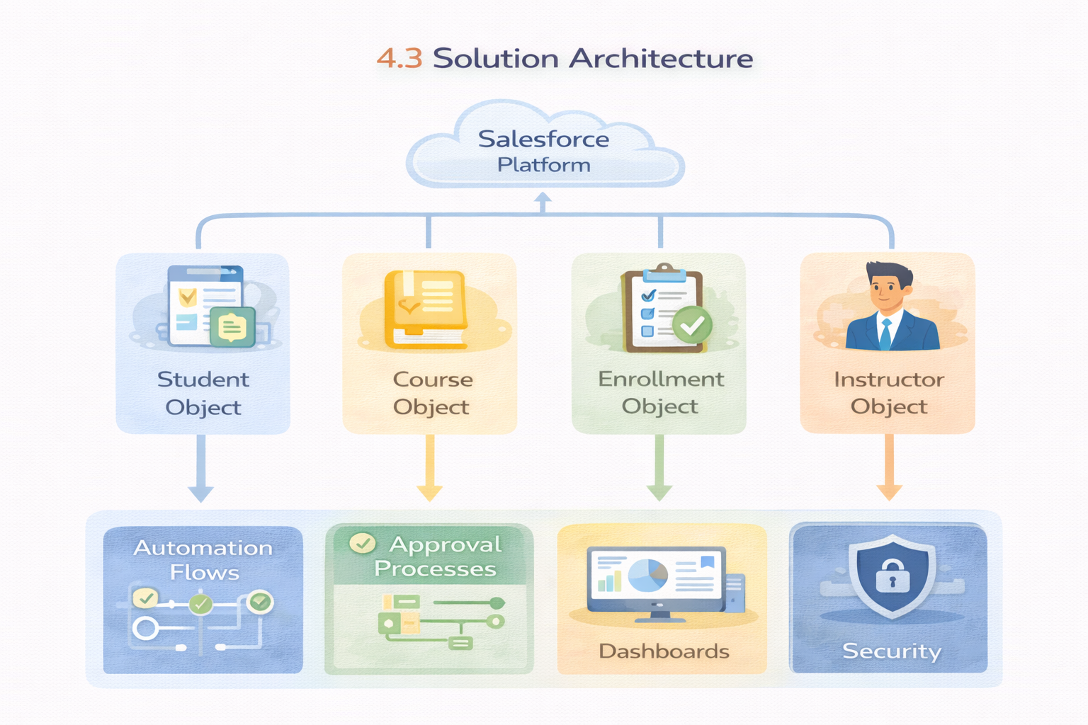

5. PROJECT PLANNING & SCHEDULING

5.1 Project Planning
- Agile methodology
- Epics → Stories → Story Points
- Sprint-based execution
- Velocity calculation used for estimation
Product Backlog, Sprint Schedule, and Estimation (4 Marks)
Use the below template to create product backlog and sprint schedule

Project Tracker, Velocity & Burndown Chart: (4 Marks)
Sprint | Total Story Points | Duration | Sprint Start Date | Sprint End Date (Planned) | Story Points Completed (as on Planned End Date) | Sprint Release Date (Actual)
Sprint-1 | 20 | 6 Days | 24 Oct 2022 | 29 Oct 2022 | 20 | 29 Oct 2022
Sprint-2 | 20 | 6 Days | 31 Oct 2022 | 05 Nov 2022
Sprint-3 | 20 | 6 Days | 07 Nov 2022 | 12 Nov 2022
Sprint-4 | 20 | 6 Days | 14 Nov 2022 | 19 Nov 2022

6. PROJECT DEVELOPMENT PHASE – DETAILED IMPLEMENTATION

Milestone 1: Salesforce Developer Account Creation
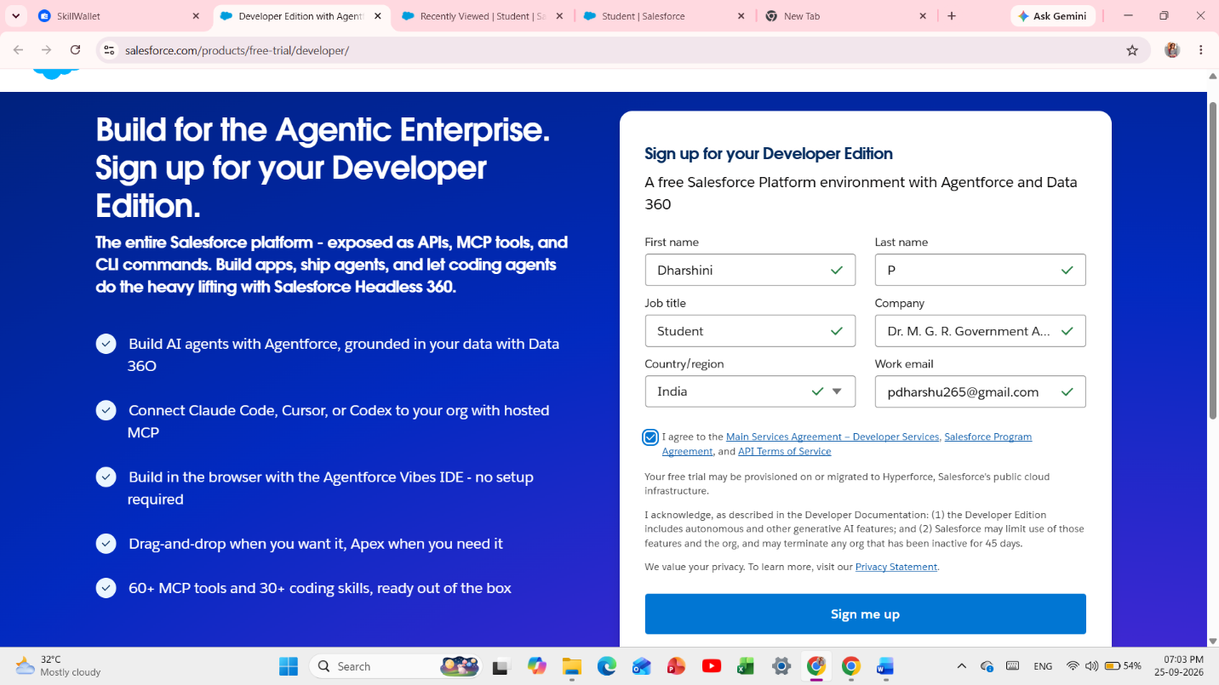

- Go to https://developer.salesforce.com/signup.
- Fill First Name, Last Name, Email, Role: Developer, Company: College Name, Country: India, and Username in the format yourname@college.com.

Milestone 2: Custom Object Creation
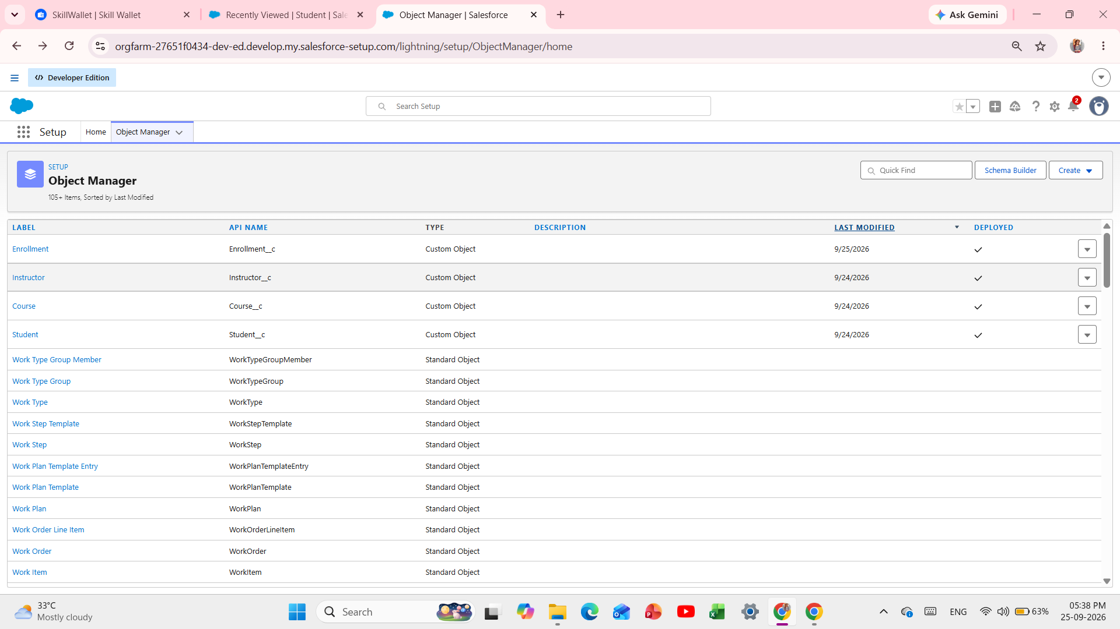

Fig 1: Custom Objects Created

- Setup → Object Manager → Create → Custom Object.
- Label: Student; Plural: Students; API: Student__c; Record Name: Student Name (Text); enable Allow Reports and Allow Search.
- Similarly create Course__c, Instructor__c, and Enrollment__c.

Milestone 3: Fields Creation

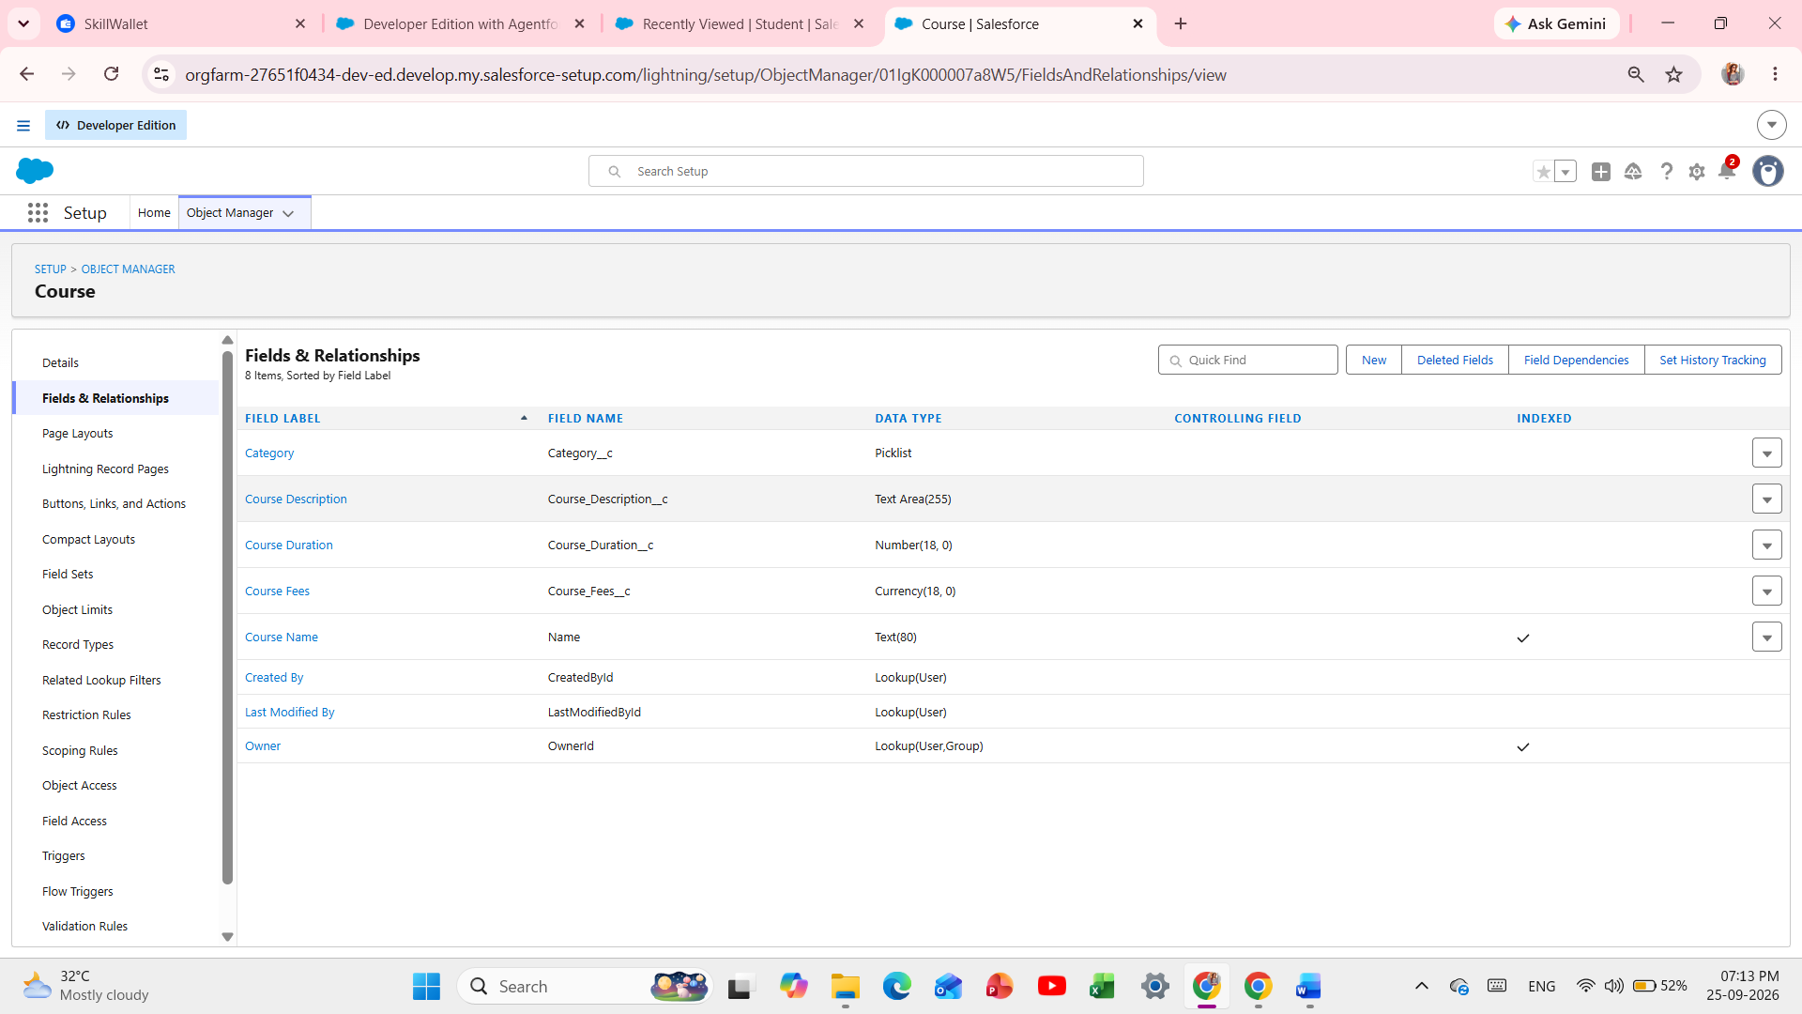

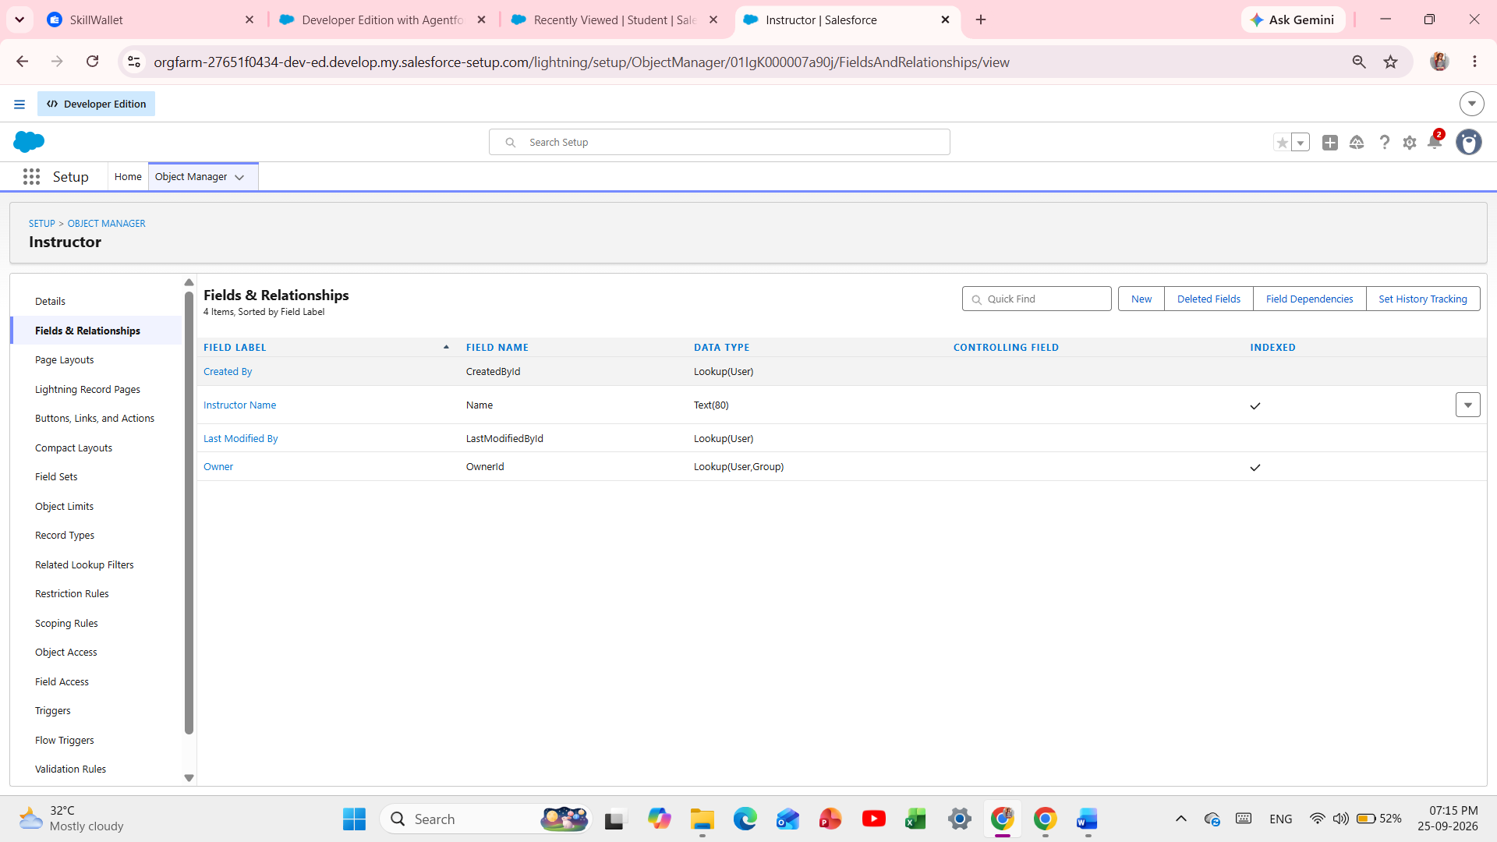
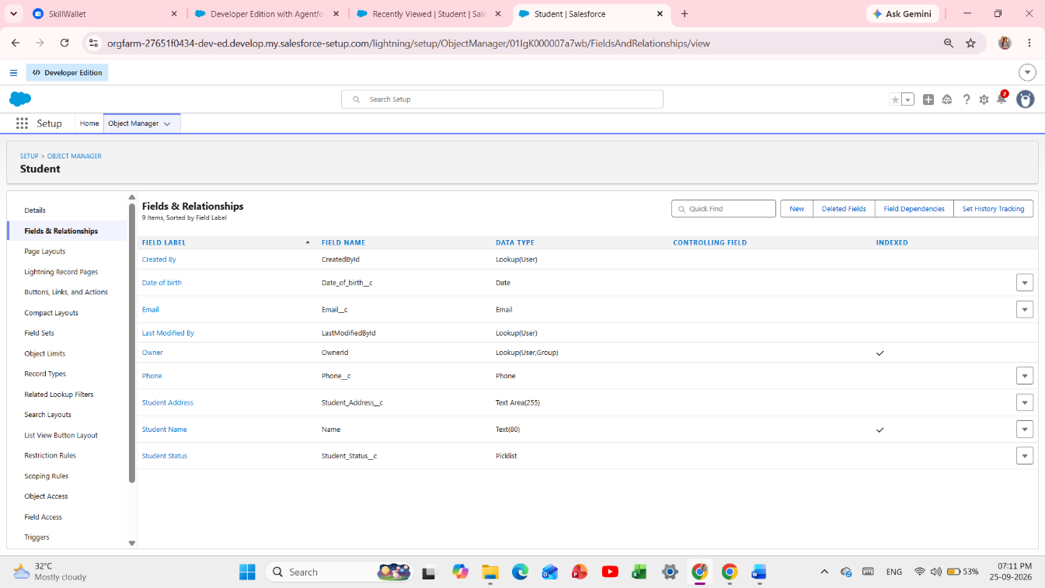

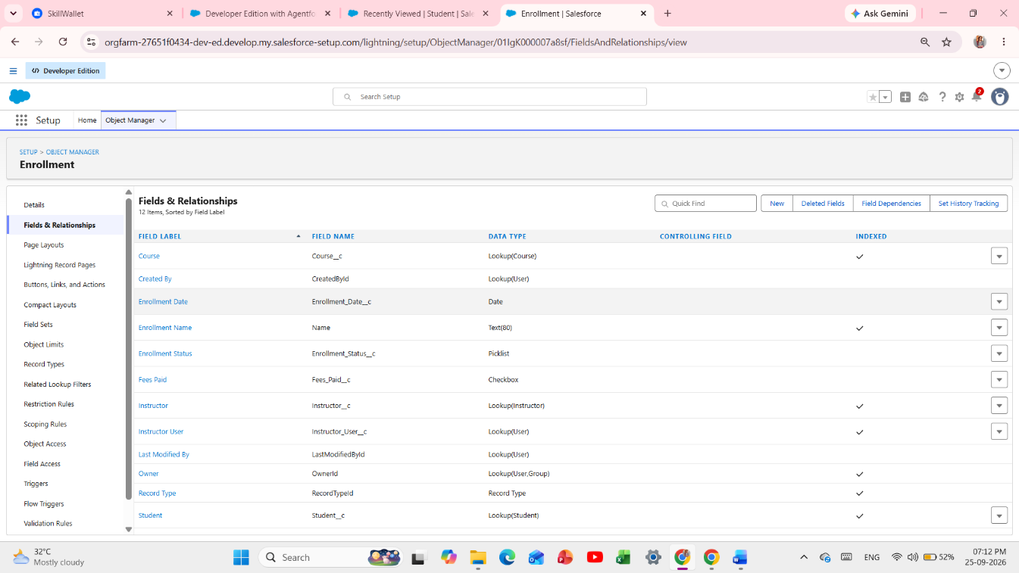

Object fields / Fields & Relationships showing the configured Student, Course, Instructor and Enrollment fields

- Student__c: Email (Email), Phone (Phone), DOB (Date), Status (Picklist: Active, Inactive, Graduated), Address (Long Text Area).
- Course__c: Category (Picklist: Technical, Language, Non-Technical), Duration (Number), Course Fee (Currency), Description (Long Text).
- Instructor__c: Instructor Code (Text: INSTR_A, INSTR_B, INSTR_C), Expertise (Picklist), Phone, Email.
- Enrollment__c: Student (Lookup Student__c), Course (Lookup Course__c), Instructor (Lookup Instructor__c), Instructor User (Lookup User – Critical), Enrollment Date (Date), Enrollment Status (Picklist: Requested, Approved, Rejected), Fees Paid (Checkbox), Total Amount (Currency).

Milestone 4: Relationships
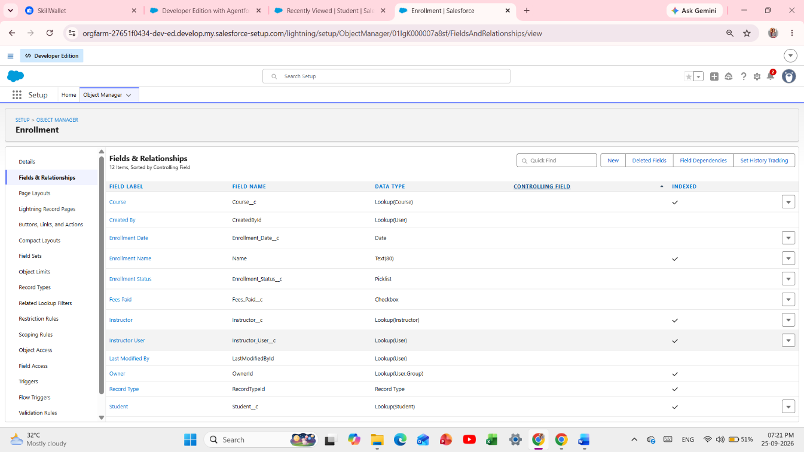

Enrollment lookup relationships to Student, Course and Instructor
(Paste the Salesforce screenshot here)

- Relationships are created through the Lookup fields defined in Milestone 3.

Milestone 5: Validation Rules
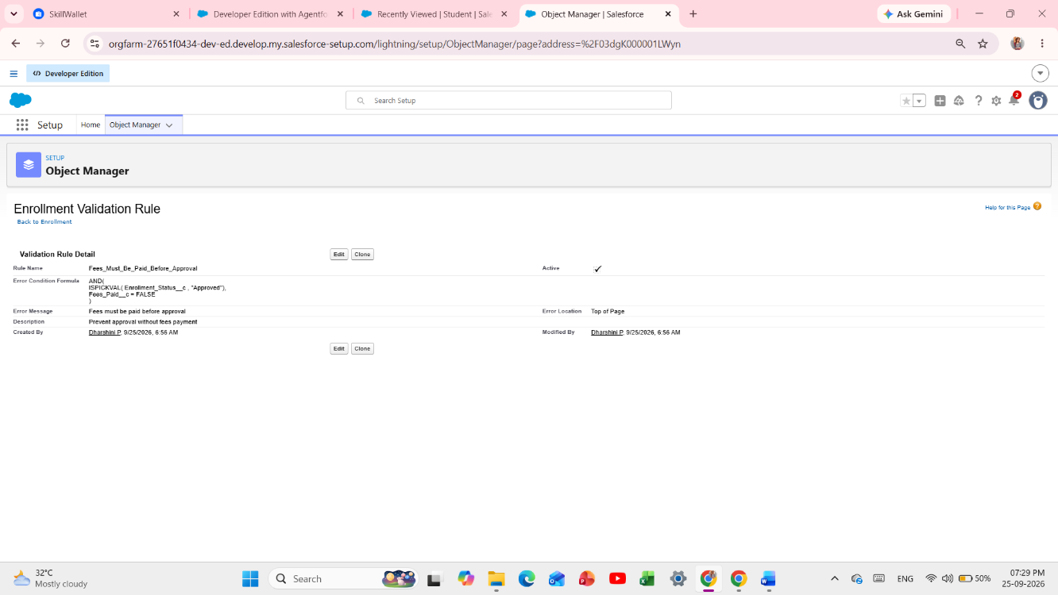

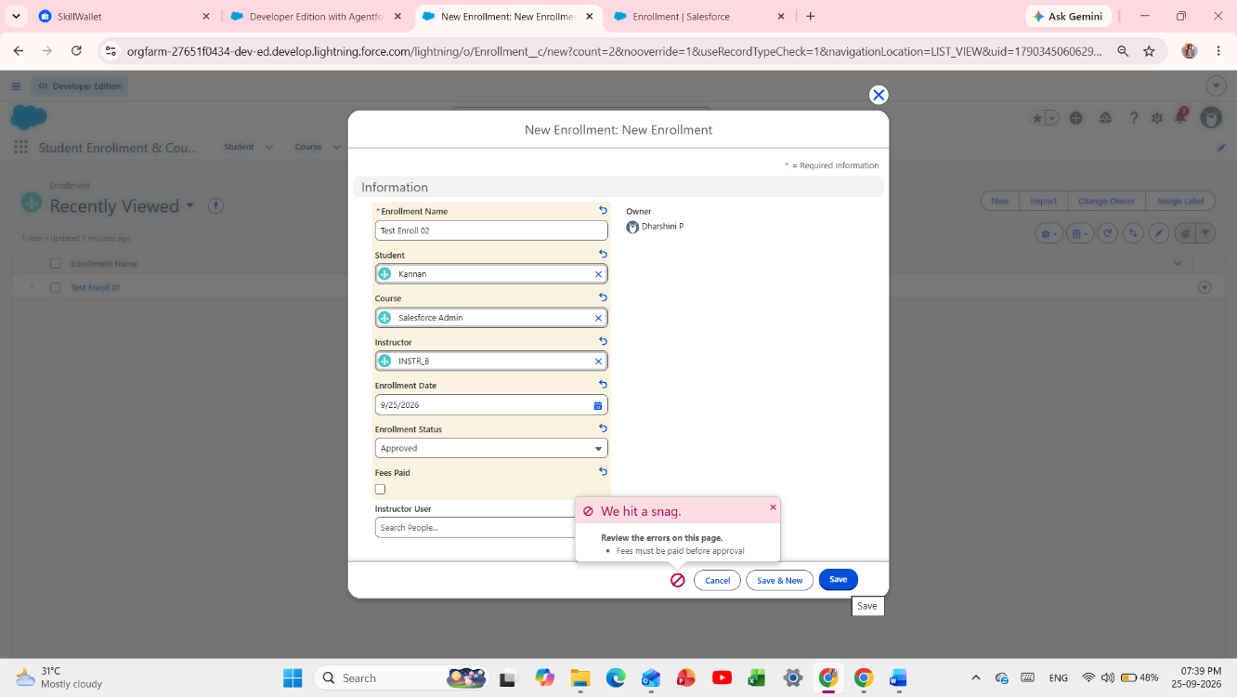

Validation Rule error showing “Fees must be paid before approval” in red

Fig 2: Validation Rule Testing

- Rule 1 – Student_Email_Domain_Validation: Object Student__c → Validation Rules → New. Formula: NOT(CONTAINS(Email__c, "@student.edu")). Error: Email must be valid student institutional email. Location: Email field.
- Rule 2 – Fees_Must_Be_Paid_Before_Approval: Object Enrollment__c. Formula: AND(ISPICKVAL(Enrollment_Status__c, "Approved"), Fees_Paid__c = FALSE). Error: Fees must be paid before approving enrollment.

Milestone 6: Approval Process
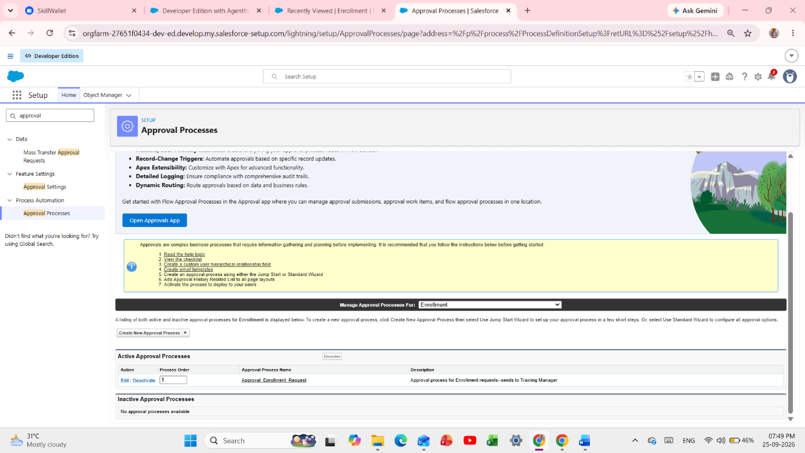
Approval Process page showing the enrollment approval process is Active
[Insert screenshot here]

Fig 3: Approval Process Active

- Setup → Approval Processes → Select Enrollment__c → Create New Approval Process → Use Standard Setup.
- Name: Approval_Enrollment_Request. Entry Criteria: Enrollment_Status__c = Requested. Approver: Training Manager User.
- Final Approval Action: Field Update → Enrollment_Status__c = Approved.
- Final Rejection Actions: Field Update → Enrollment_Status__c = Rejected + Email Alert to Student.
- Activate the approval process.

Milestone 7: Tabs
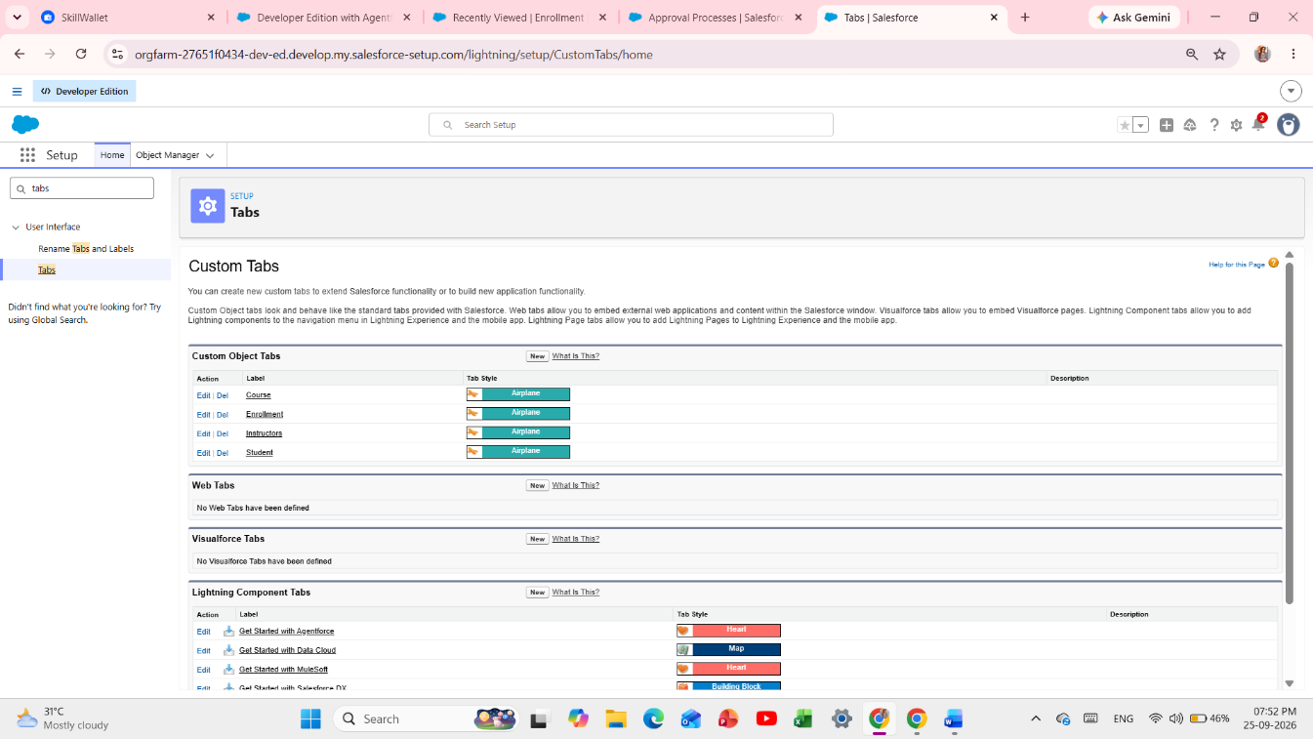

Custom Object Tabs showing Student, Course, Instructor and Enrollment tabs

- Setup → Tabs → Custom Object Tabs → New → Select Student → Tab Style → Next → Add to all Profiles → Save.
- Repeat for Course, Instructor, and Enrollment.

Milestone 8: Lightning App
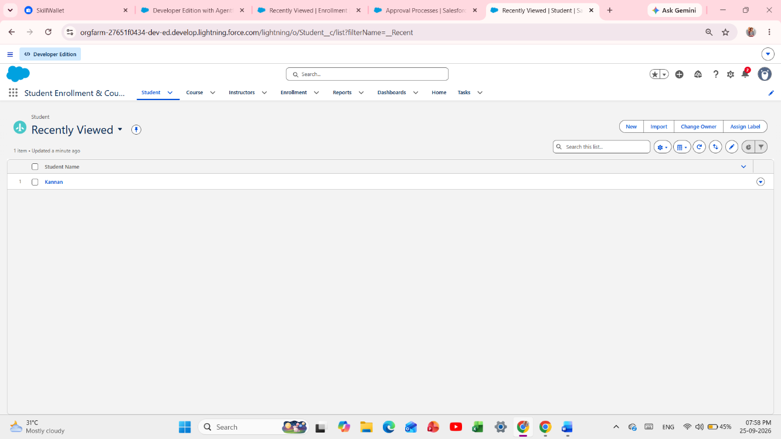
Student Enrollment & Course Management Lightning App showing Student, Course, Instructor, Enrollment, Reports and Dashboards tabs
[Insert screenshot here]

Fig 4: Lightning App with Tabs

- Setup → App Manager → New Lightning App.
- App Name: Student Enrollment & Course Management. Navigation: Standard. Profiles: System Admin.
- Add Tabs: Student, Course, Instructor, Enrollment, Reports, Dashboards, Home → Save & Finish.

Milestone 9: Page Layouts
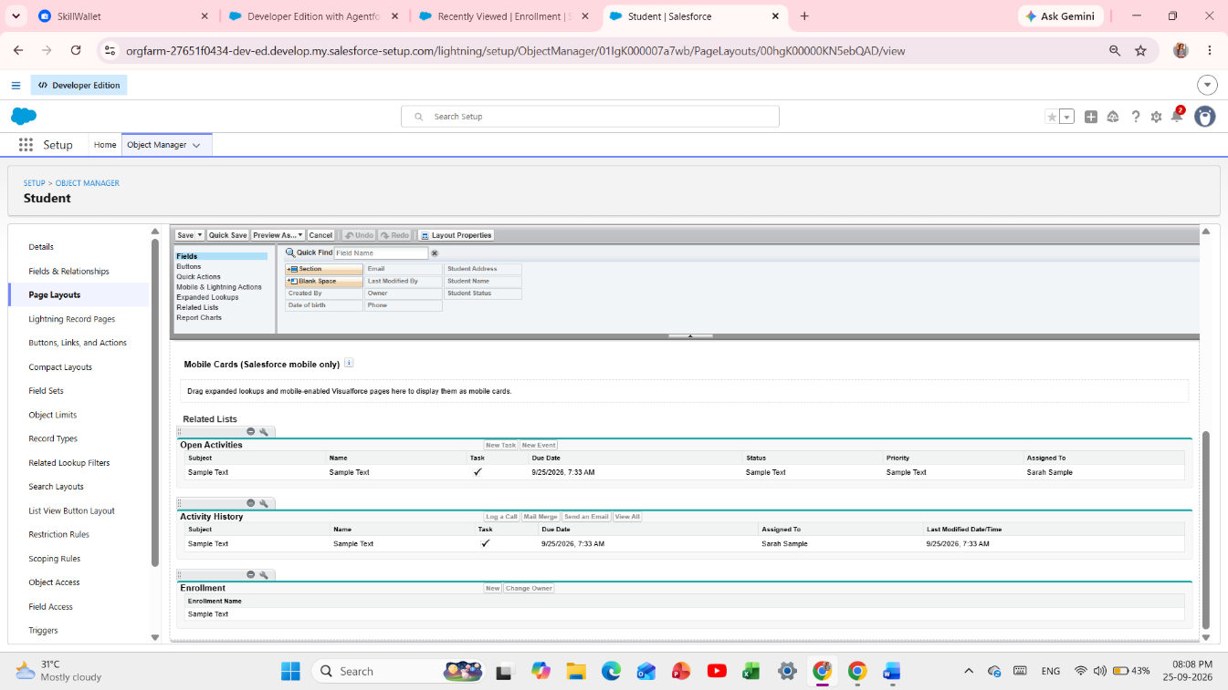

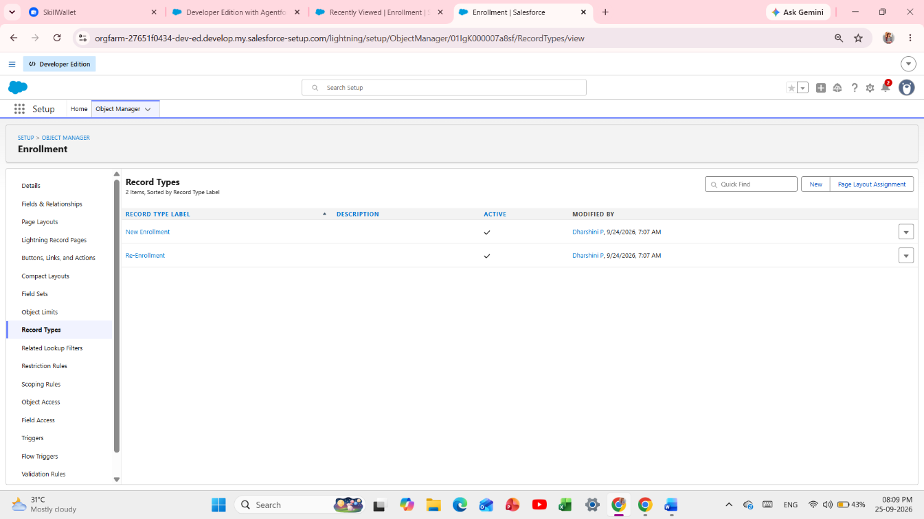

Enrollment Record Types and Page Layout / Related Lists configuration
(Paste the Salesforce screenshot here)

- Setup → Object Manager → Student__c → Page Layouts → Edit Layout → Related Lists → Drag Enrollments Related List → Save.
- Repeat for Course__c and Instructor__c.
- Create Record Types for Enrollment: New Enrollment and Re-Enrollment, assigning different page layouts.

Milestone 10: Flows – Most Important

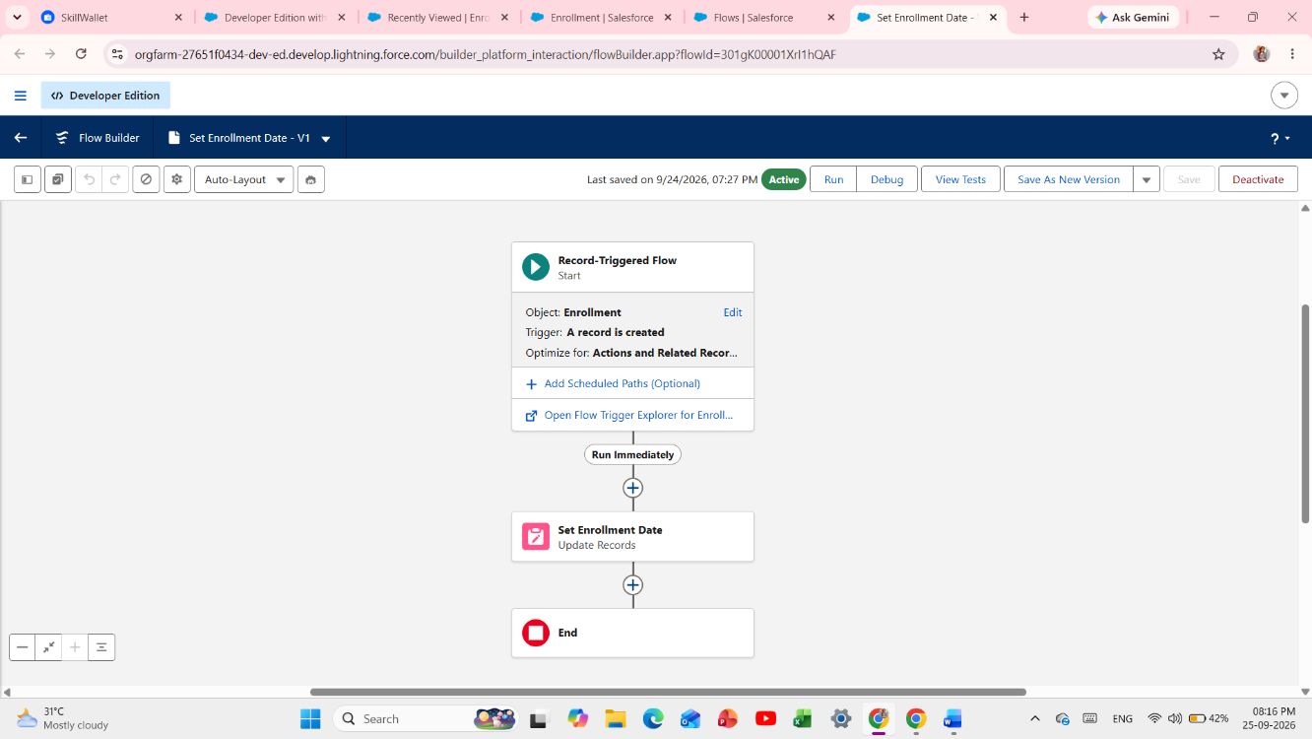
Flows list showing the active automation flows, including SetEnrollmentDate, AutoAssign_Instructor, and Change_Owner_To_Instructor
[Insert screenshot here]

Fig 5: Flows – Auto Assign (Active)

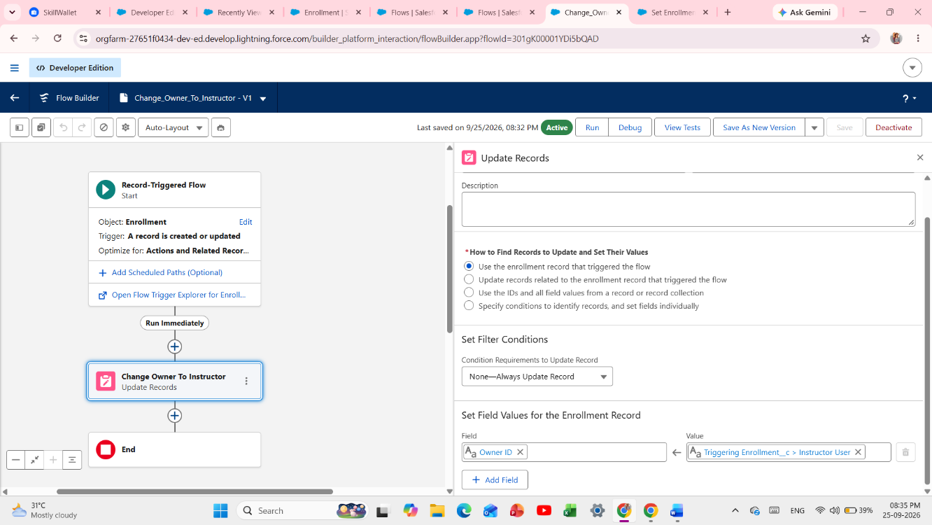
Flow 4 Owner Change logic showing Owner_Id = $Record.Instructor_User__c for private OWD sharing
[Insert screenshot here]

Fig 6: Owner Change Flow – Critical for Private OWD

- Flow 1 – Auto-Populate Enrollment Date: Record-Triggered Flow on Enrollment__c when a record is created → Update Records → Enrollment_Date__c = $Flow.CurrentDate → Save as SetEnrollmentDate → Activate.
- Flow 2 – Send Email When Approved: Record-Triggered Flow on Enrollment__c update → Condition Status = Approved → Get Student__c → Email Alert → Update Student Status = Active → Activate.
- Flow 3 – Auto-Assign Instructor Based on Course Category: Trigger on Enrollment__c Created/Updated → Get Course__c → Decision by Course Category → Technical = INSTR_A; Language = INSTR_B; Non-Technical = INSTR_C → Update Enrollment Instructor__c with found Instructor Id → Activate.
- Flow 4 – Owner Change for Private Sharing: Trigger on Enrollment__c Created/Updated → Condition Instructor_User__c != null → Update OwnerId = $Record.Instructor_User__c → Save as Change_Owner_To_Instructor → Activate. This makes Enrollment Private OWD work by allowing the assigned instructor to own and access the record.

Milestone 11: Reports

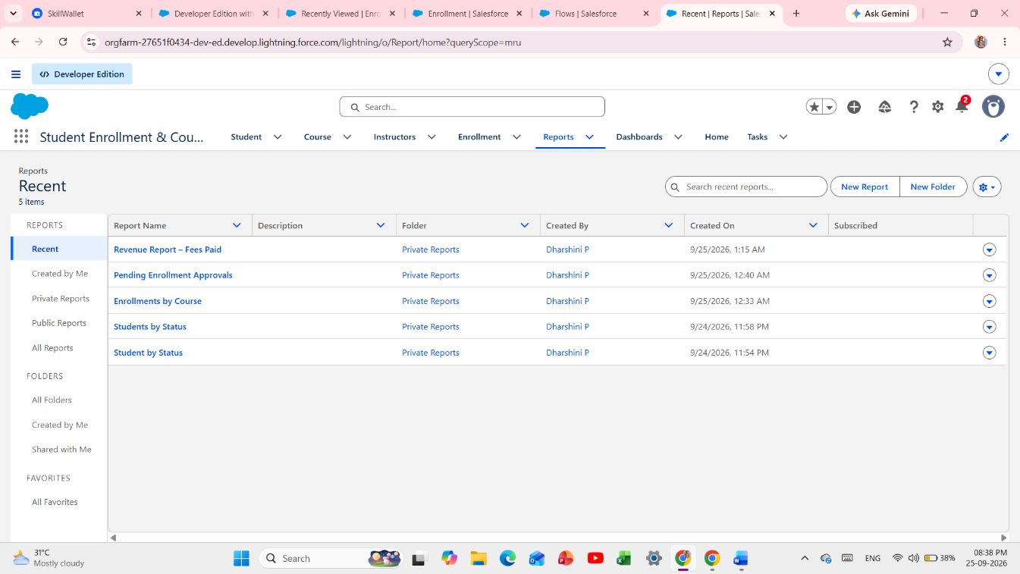

Reports list showing Students by Status, Enrollments by Course, Pending Approvals and Revenue Report
(Paste the Salesforce screenshot here)

- Students by Status: Reports → New Report → Students → Group by Status.
- Enrollments by Course: Reports → New Report → Enrollments → Group by Course Name.
- Pending Enrollment Approvals: Filter Status = Requested.
- Revenue Report: Filter Fees Paid = TRUE → Group by Course → Summarize Total Amount.

Milestone 12: Dashboards

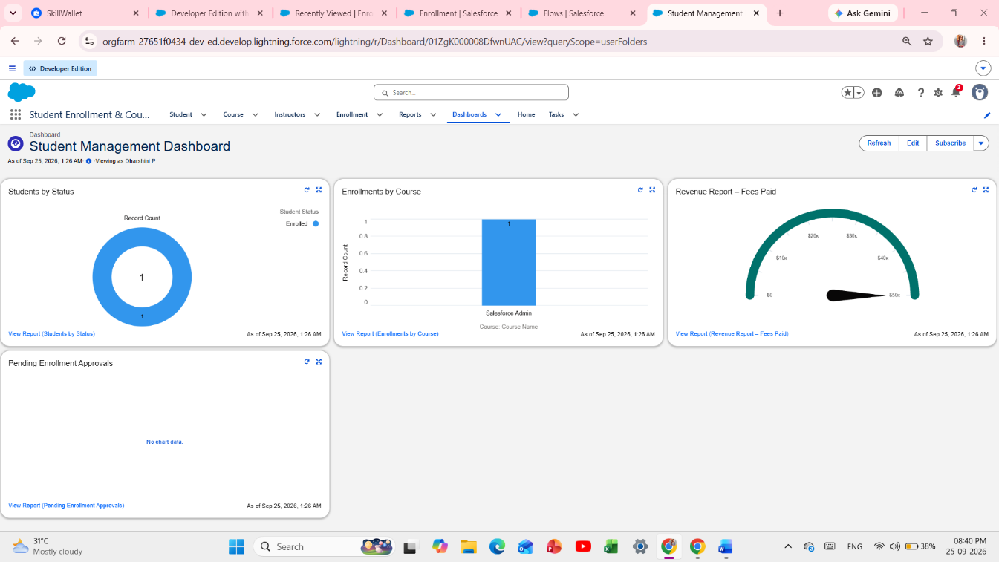

Student Management Dashboard with Donut, Bar, Table and Gauge components

- Dashboards → New Dashboard → Name: Student Management Dashboard.
- Add components: Donut Chart from Students by Status, Bar Chart from Enrollments by Course, Table from Pending Approvals, and Gauge from Revenue Report → Save.

Milestone 13: Security Setup
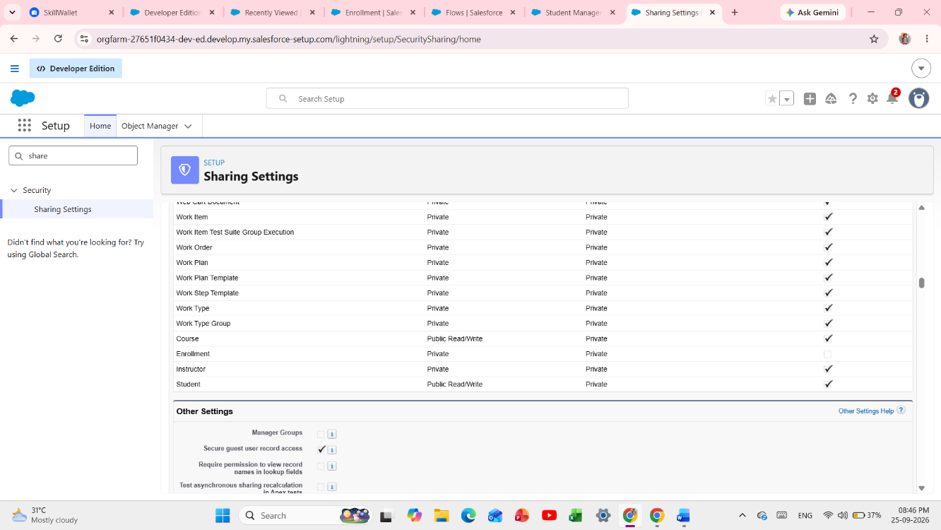
Setup → Sharing Settings showing Student__c = Public Read/Write, Course__c = Public Read/Write, Enrollment__c = Private
[Insert screenshot here]

Fig 7: Organization-Wide Defaults – Sharing Settings

- Setup → Sharing Settings → Organization-Wide Defaults.
- Student__c: Public Read/Write – all users need to see students.
- Course__c: Public Read/Write – course catalog is public.
- Enrollment__c: Private – only the assigned instructor should see the enrollment, enforced through the Owner Change Flow.
- Profiles: Clone System Admin to create Enrollment Officer Profile with Enrollment Read/Create/Edit, Student Read, and Course Read. Instructor Profile: Enrollment Read-only.
- Permission Sets: Dashboard Editor and Custom Object Access – assign to appropriate users.

7. FUNCTIONAL & PERFORMANCE TESTING
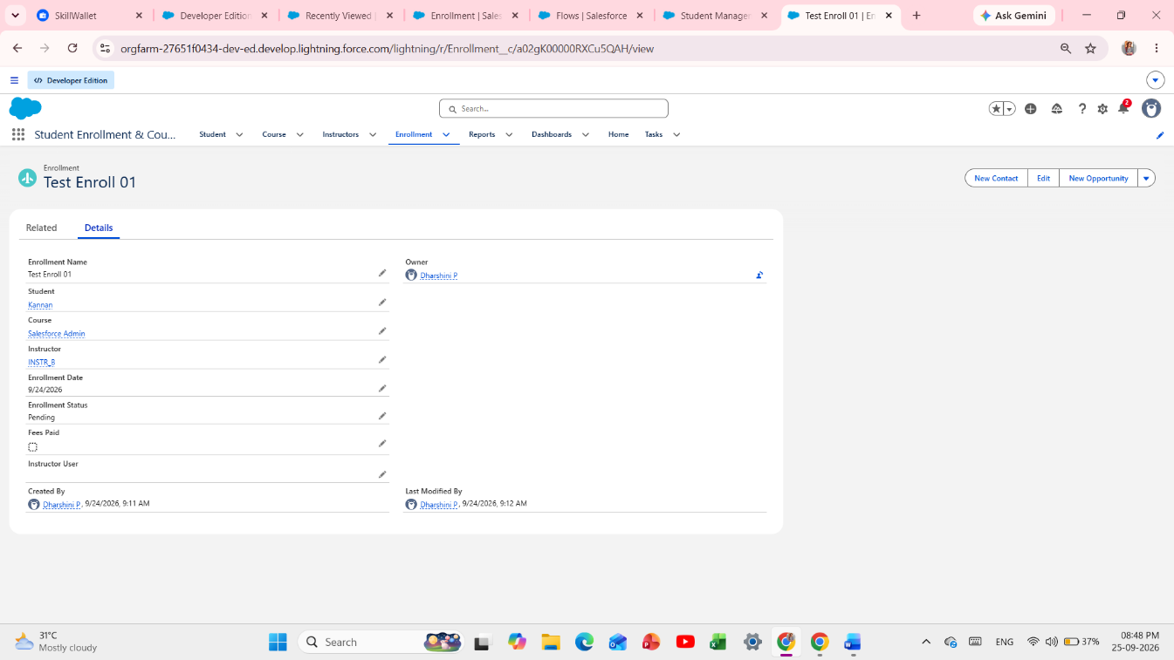
Overall Salesforce testing evidence: validation error, approval, flow, reports/dashboard or enrollment record proof
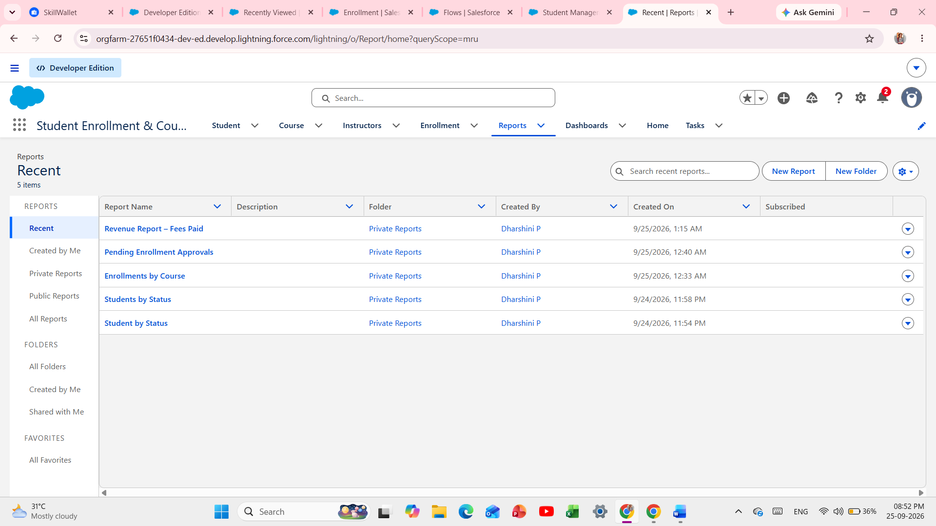
Reports page showing “Students by Status” and “Enrollments by Course” reports

Fig 8: Reports – Students by Status & Enrollments by Course
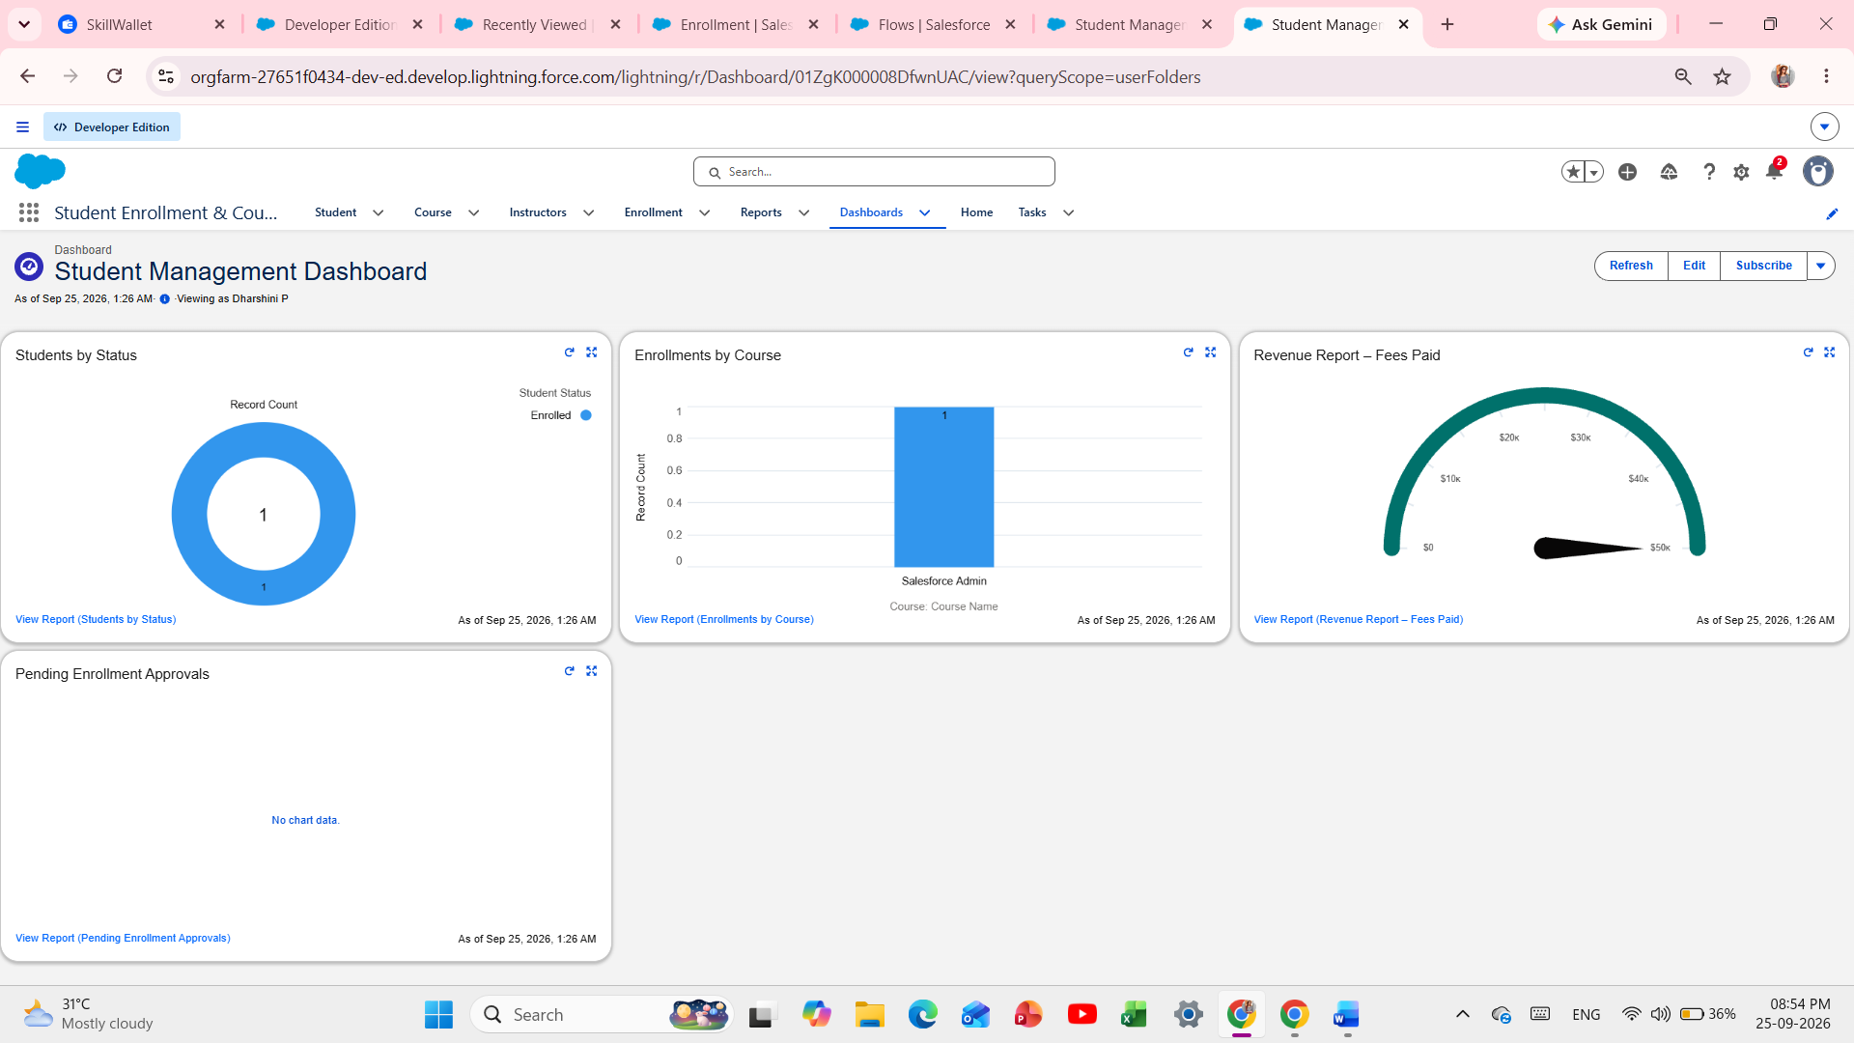
Dashboard showing the Donut Chart and Bar Chart components

Fig 9: Student Management Dashboard

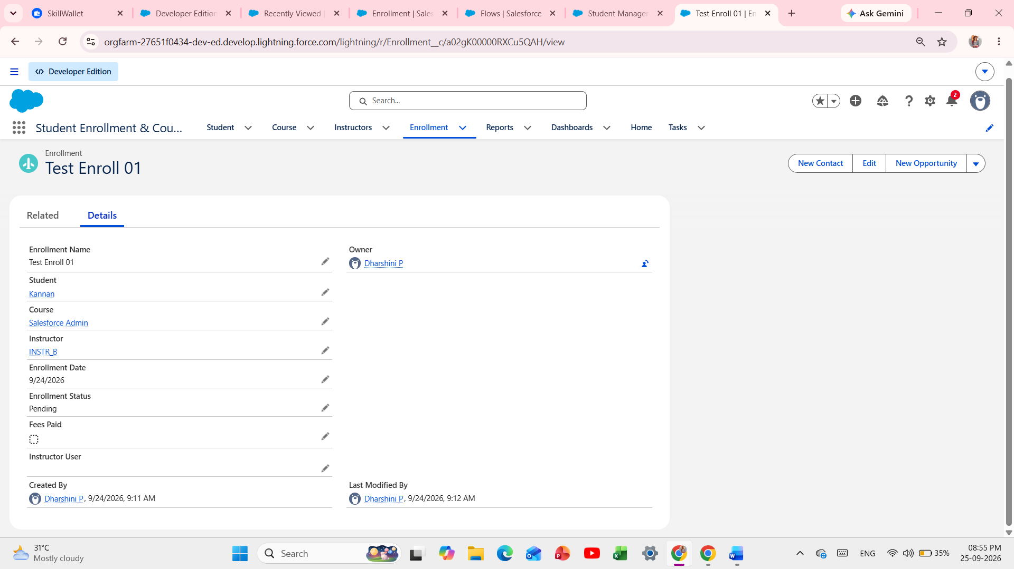
Enrollment record showing Owner = Instructor User as proof of owner-based private sharing

Fig 10: Enrollment Owner Proof – Instructor User

Test Case | Test | Expected Result | Result
TC-01 | Create Student with invalid email | Validation error | PASS
TC-02 | Create Enrollment without Fees Paid and Approve | Validation error | PASS
TC-03 | Create Enrollment with Status Requested | Approval process triggered | PASS
TC-04 | Create Enrollment | Enrollment Date auto-filled today | PASS
TC-05 | Create Enrollment with Technical Course | Instructor A assigned | PASS
TC-06 | Create Enrollment with Instructor User = Instructor1 | Owner changes to Instructor1; other instructors cannot see record | PASS
TC-07 | Check Reports count matches records | Counts match records | PASS
TC-08 | Dashboard refresh | Dashboard updates successfully | PASS

Screenshots Attached: Sharing Settings, Flow Active List, Object List, Validation Error, Owner Change Proof, Reports, and Dashboard.

8. ADVANTAGES & DISADVANTAGES

Advantages
- Centralized data in a single Salesforce org
- Automated workflows reduce manual effort by approximately 80%
- Real-time reporting and dashboards
- Secure private sharing – instructors see only their enrollments
- Scalable and cloud-based 24/7

Disadvantages
- Salesforce dependency and licensing cost
- Requires initial configuration effort
- Needs training for non-technical staff

9. CONCLUSION
- SECMS successfully streamlines the entire student academic lifecycle from registration to course completion. By leveraging Salesforce automation—including Validation Rules, Flows, Approval Process, and OWD Private Sharing via Owner Change Flow—the system improves data accuracy, operational efficiency, and decision-making. The project demonstrates how Salesforce can transform manual academic processes into a scalable, reliable, and user-friendly digital solution. All milestones have been implemented and tested.

10. FUTURE SCOPE
- Payment gateway integration (Razorpay, Stripe) for online fees
- Student self-service portal via Experience Cloud
- Analytics-driven insights with Einstein Analytics
- Mobile access via Salesforce Mobile App
- Certificate generation automation
- Integration with LMS

11. APPENDIX
Item | Details
Source Code | Salesforce Configuration (Flows, Objects, Validation Rules)
Dataset | Salesforce Custom Objects
GitHub | https://github.com/pdharshu265-dev
Demo Video | https://drive.google.com/file/d/1qAhAmp5QUOpQooPwYtHvH486TBdd8-Tb/view?usp=sharing
Developer Org | https://orgfarm-27651f0434-dev-ed.develop.lightning.force.com
Team Members | 4 Members
Members Name | Bharathi. K  Dharani Sri. G  Dharshini. S  Dhivya. C  Dharshini. P
Project Type | Salesforce Administrator with Automation
Prepared By | Dharshini. P, Dr. M. G. R Government Arts and Science College for Women, Villupuram.
Date | September 2026

THANK YOU

